Boundary Waters Canoe Area Wilderness
The Boundary Waters Canoe Area Wilderness (BWCAW or BWCA), is renowned as a destination for both canoeing and fishing on its many lakes and is the most visited wilderness in the United States.
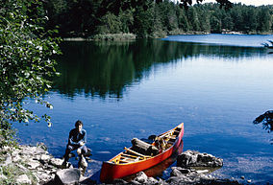
Recreation
The BWCAW is renowned as a destination for both canoeing and fishing on its many lakes and is the most visited wilderness in the United States. Although there are numerous drive-in campgrounds surrounding the wilderness, most campsites in the BWCAW are accessible only by water. Most lakes and rivers are interconnected by portage trails, resulting in over 1,000 miles (1,600 km) of canoe routes.
Canoeing | As of 1999, about 75% of the BWCAW's water area was reserved for non-motorized boat travel.
Fishing | Game species include northern pike, walleye, largemouth and smallmouth bass, yellow perch, whitefish, and lake trout, among others
Hiking | The Border Route Trail runs east-west for over 60 miles (97 km) through the eastern BWCAW, following the ridges between the long border lakes such as Loon, South, and Rose.

Notable people associated with the BWCAW
Sigurd Olson, Minnesota author and conservationist, wrote extensively about the Boundary Waters and worked to ensure preservation of the wilderness. Click here to learn more.
Dorothy Molter, known as the "Rootbeer Lady," lived in the BWCAW for 56 years (alone after 1948) until her death in 1986, and was the last resident of the BWCA.
Benny Ambrose lived alone on Ottertrack Lake until his death in 1982, leaving Dorothy Molter as the last remaining full-time resident.

