Learning Community Frameworks
  - Prepared by Carolyn Holcroft to inform discussion in the Equity and Education Committee

What are our learning communities “about”? What is their connection to student equity?

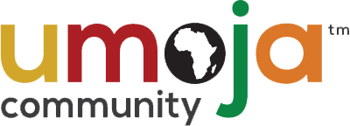

Nationally
MISSION STATEMENT: Umoja, (a Kiswahili word meaning unity) is a community and critical resource dedicated to enhancing the cultural and educational experiences of African American and other students. We believe that when the voices and histories of students are deliberately and intentionally recognized, the opportunity for self-efficacy emerges and a foundation is formed for academic success. Umoja actively serves and promotes student success for all students through a curriculum and pedagogy responsive to the legacy of the African and African American Diasporas.

VISION STATEMENT: To transform, enrich and advance the lives of students by infusing culturally relevant pedagogy and practices.

“Focused on the retention and academic success of African American students”
“program retention, persistence, and success” [data]

At Foothill
The following is from the Foothill College Umoja Annual Program Review completed for 2016-2017:

We developed the following 5 program objectives, some of which were inspired by Umoja’s Practices and some arose from our local needs.

Umoja Program Objectives—Students will
- Communicate their authentic (academic, standard, Black English, and theoretical) student voice across various formats.
- Complete an abbreviated and comprehensive SEP
- Become aware of their connectedness to African Diaspora
- Set, reflect on, and make progress towards academic goals
- Participate and take a leadership role in campus activities, committee, or club

Through qualitative assessments, curriculum review and information from our Counselor Tracee Cunningham, all of our program objectives were met.
- In our curriculum students read, discussed and produced work in Black, standard, academic and theoretical English
- All students completed an abbreviated and those who stayed enrolled beyond fall 2016 completed a comprehensive SEP with Tracee Cunningham
- Through text choice, community events, and Umoja conferences, students grew in their awareness regarding the African Diaspora and its current effect on them today
- Through student presentations, transfer and OWL scholar workshops, students made progress towards their academic goals
- Our students presented to ASFC for funds for and event and graduation stoles. Many were athletes and a handful joined BSU, Victory on the Hill, or the Dance Team

The mission of the Puente Project is to increase the number of educationally underserved students who enroll in four-year colleges and universities, earn degrees, and return to the community as leaders and mentors to future generations. Puente is open to all interested students.

The Puente Project was co-founded in 1981 by Felix Galaviz, Counselor, and Patricia McGrath, English Professor, at Chabot College in Hayward. The co-founders were concerned about the high drop-out rate of Hispanic/Latino students on campus. They believed that the best hope of reversing this trend was to develop a system that would serve the needs of the whole student in a carefully monitored, highly accountable and culturally integrated way.

Puente's model was created on the assumption that any student, regardless of past performance, has the potential to succeed academically if provided with the right tools and learning environment. Therefore, Puente serves students from the full range of demonstrated ability levels. Puente’s model combines an academically challenging curriculum with a cross-functional support network of specially trained teachers and counselors, parents, families and members of the local community. Puente is co-sponsored by the University of California and the California Community Colleges, with additional funding provided by the college.

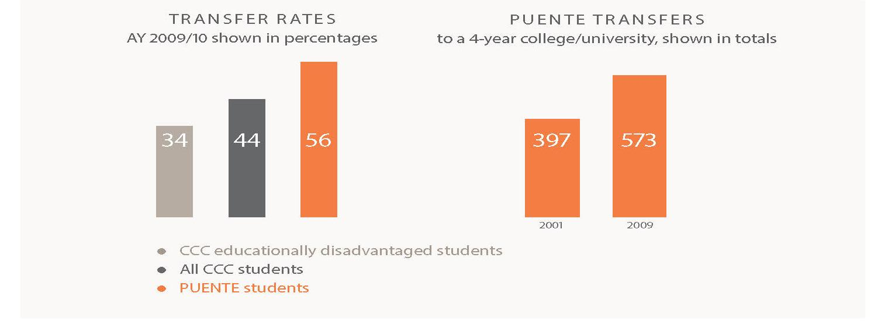

Puente Students:
- Enroll in English classes with a focus on Latino culture, history and experience
- Take classes together for a supportive and stimulating environment
- Work with a counselor to explore career options and develop academic goals
- Receive professional mentorship
- Participate in service learning for college credit
- Visit colleges and attend conferences and cultural events

https://puente.berkeley.edu/about
https://puente.santarosa.edu/puente-model

